
STUDENT CASE STUDY EXECUTION REPORT
Department | FED
Subject | DSA-2
Academic Year | I-III Semester (2025-26)
Faculty Name | G.Mamtha
Student Name | K.Hemanth
Roll Number | 2520030230
Branch | CSE
Course Outcome | CO4

Case Study Topic: EventSphere – Smart Event Planning & Management System Using Shortest Path Algorithms
Work Done Summary:
The application of Dijkstra’s Algorithm, Bellman-Ford Algorithm, and Floyd-Warshall Algorithm in optimizing event logistics and route planning within the EventSphere Smart Event Management System.
The system was designed to manage multiple event venues, transport routes, and delivery paths for resources such as catering, decorations, and participant transportation. Each venue is represented as a graph node, while travel paths between venues are represented as weighted edges.
Three shortest-path algorithms were implemented to compare their performance and correctness in different graph conditions:
- Dijkstra’s Algorithm for positive-weighted graphs
- Bellman-Ford Algorithm for graphs containing negative weights
- Floyd-Warshall Algorithm for all-pairs shortest path analysis
Implementation Details:
- Created Graph class using adjacency matrix and adjacency list to represent event venues and routes with weights (travel time/cost).
- addEdge(u, v, w) method adds a weighted edge between two venues u and v.
- dijkstra(source) method computes shortest paths from the source to all other venues using Dijkstra’s Algorithm (works for positive weights).
- bellmanFord(source) method computes shortest paths and detects negative weight cycles if present.
- relax(u, v, w, dist[]) method updates the shortest distance if a better path is found during Bellman-Ford execution.
- floydWarshall() method computes shortest paths between all pairs of vertices using Floyd-Warshall Algorithm.
- printPath(parent[], j) method reconstructs and prints the shortest route from source to destination.
- printSolution(dist[]) method displays the shortest distances from source to all event venues.
- detectNegativeCycle() method checks whether the graph contains any negative weight cycle.
- comparePerformance() method compares the execution speed and efficiency of Dijkstra’s, Bellman-Ford, and Floyd-Warshall algorithms.
- Main method creates the event graph, executes all three shortest path algorithms, displays results, and analyzes their suitability for different event-routing scenarios.
Result Screenshots/ Output:
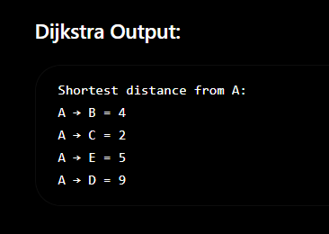
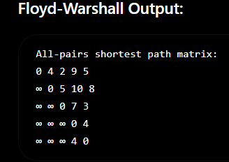
Time Complexity Analysis:
Algorithm | Complexity
Dijkstra | O(V²)
Bellman-Ford | O(VE)
Floyd-Warshall | O(V³)

GitHub Link:https://github.com/hemanthkasani25-web/DSA_2
Student Signature | Faculty Signature

